**Support Vector Machines (SVM)**

Support Vector Machines, often abbreviated as SVM, are powerful supervised machine learning models used for classification and regression tasks. SVM is particularly popular for its effectiveness in high-dimensional spaces and its versatility in various domains.

**Key Concepts:**

1. **Margin:** SVM aims to find a hyperplane that maximizes the margin between classes. The margin is the distance between the hyperplane and the nearest data points from each class, known as support vectors.
2. **Hyperplane:** In a two-class problem, the hyperplane is the decision boundary that separates the two classes. In higher dimensions, it's a generalization of a straight line to a multidimensional space.
3. **Kernel Trick:** SVM can work with non-linearly separable data by mapping it into a higher-dimensional space using kernel functions. Common kernels include linear, polynomial, and radial basis function (RBF) kernels.
4. **C Parameter:** The C parameter in SVM allows for controlling the trade-off between maximizing the margin and minimizing classification errors. A smaller C value results in a larger margin but may allow some misclassifications, while a larger C value may reduce the margin to avoid misclassifications.
5. **Support Vectors:** These are data points closest to the decision boundary. They are crucial for defining the margin and the overall SVM model.

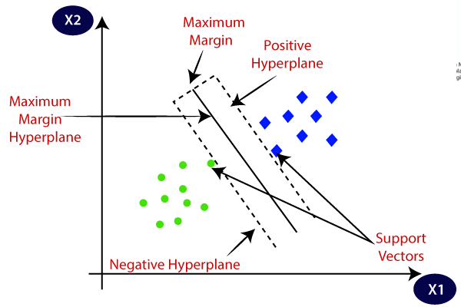

**Advantages:**

1. **Effective in High Dimensions:** SVM is highly effective in datasets with a large number of features, making it suitable for tasks like image classification and text classification.
2. **Versatile Kernels:** SVM can handle non-linear data by choosing an appropriate kernel function.
3. **Global Optimum:** The optimization problem in SVM aims to find the global optimum, leading to robust models.

**Challenges:**

1. **Sensitivity to Parameters:** Choosing the right kernel and tuning the C parameter can be challenging.
2. **Computational Complexity:** SVM can be computationally expensive for large datasets.

**Applications:**

1. **Image Classification:** SVMs are used in facial recognition, object detection, and image categorization.
2. **Text Classification:** They are employed in sentiment analysis, spam detection, and document categorization.
3. **Bioinformatics:** SVMs are applied in protein classification, gene expression analysis, and disease prediction.
4. **Finance:** SVMs are used for credit scoring, stock market forecasting, and fraud detection.

And many more.

In summary, Support Vector Machines are a powerful tool for classification and regression tasks, particularly useful in high-dimensional spaces and when you need to handle non-linear relationships in your data. Proper selection of kernels and parameter tuning are crucial for achieving the best results with SVM.